Cloud Trails

1.What is Cloud Trails ? configure a S3 bucket for cloudtrails.
- Cloud trail is an aws service used to store activity logs and api call history .
- The retention period of logs is 90 days
- We can configure cloud trails to store the logs permanently using S3 bucket.
- To efficiently use/handle millions and billions of logs , we can integreate Athena analytics service to analysis the logs .
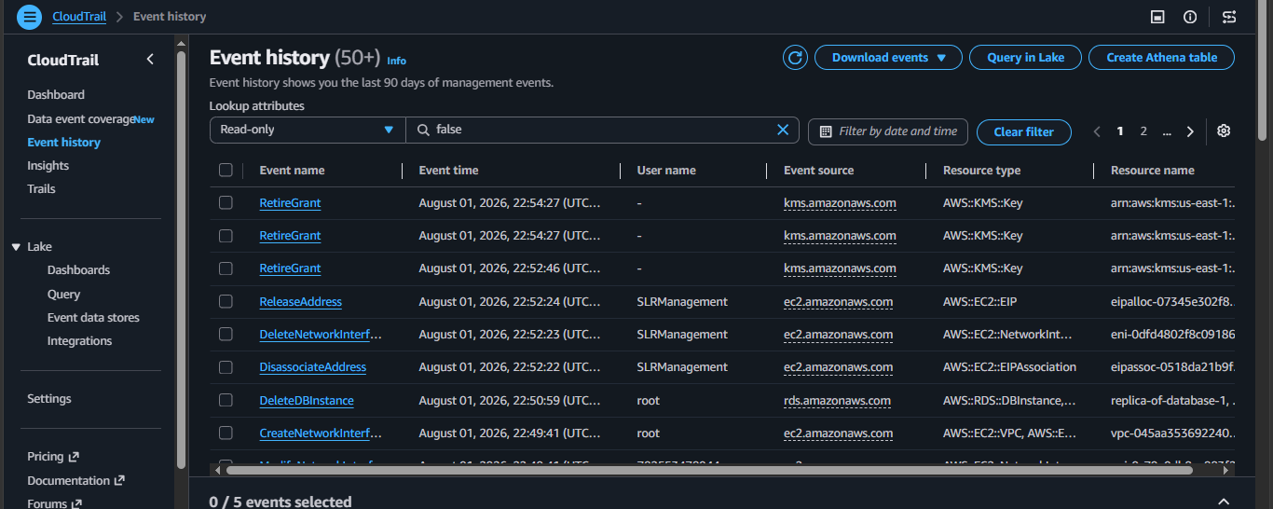

Configure a S3 bucket for cloudtrails.
Open Cloud Trails > trails >Create trails.
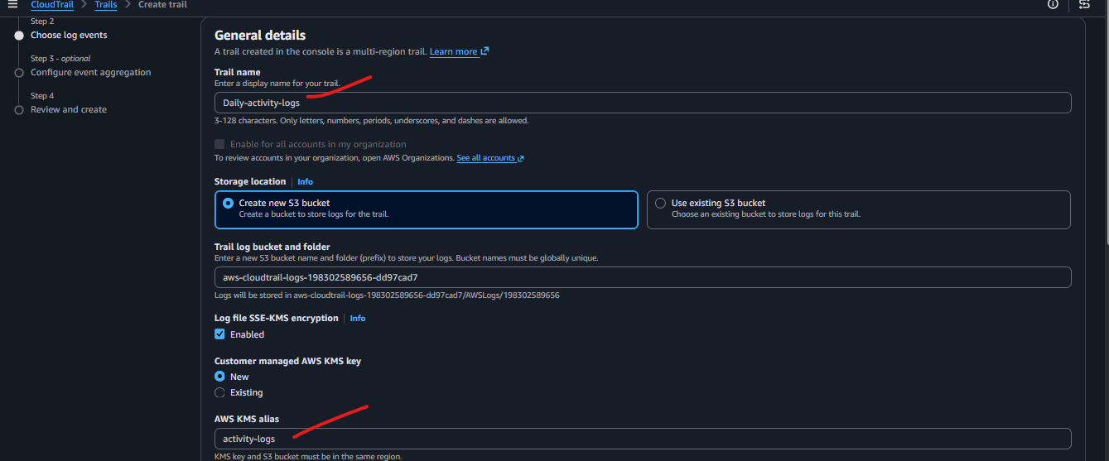
Select all required options
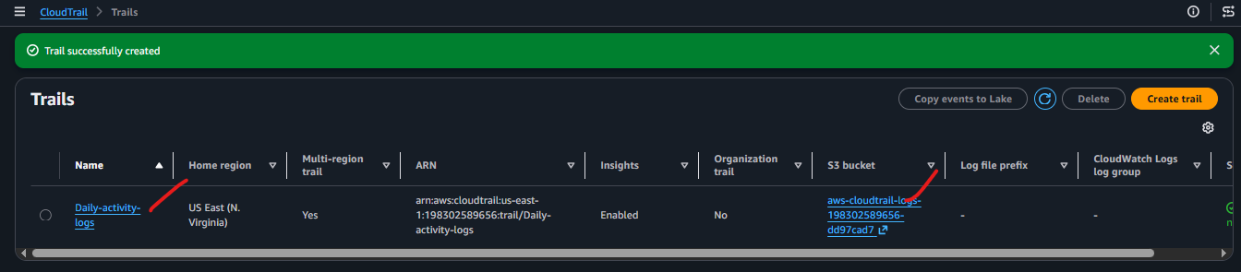
Now go to S3 bucket to check if the log bucket created or not
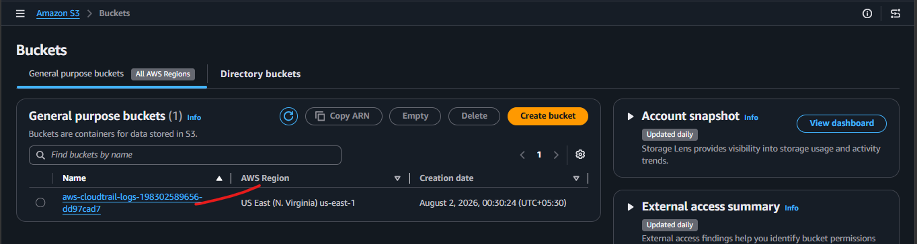
We can see the logs stored into S3 bucket.
